The Best Excavator Companies.

Top Best Excavator Companies in the World.
Caterpillar Inc. and Komatsu based in USA and Japan respectively are the top best companies in the word that design, produce and sell earth movers and excavators.
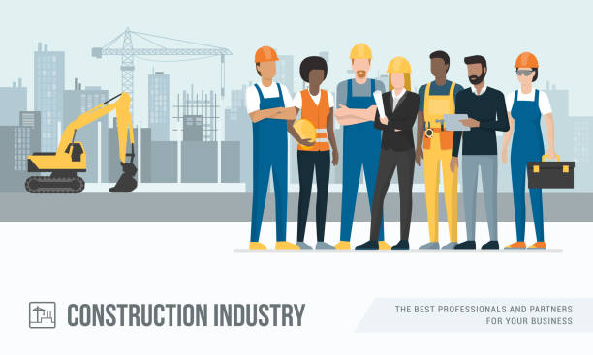

Hitachi, Volvo and Terex are also other companies that produce heavy construction equipment and make a good fraction of the world market shares. Whether you are looking for where to buy earth movers and the best quality diggers, it is better to know which is ranked where, how and why.
Depending on quality, cost of production and price of the product, various companies are occasionally preferred in the world market.
TABLE OF CONTENTS
- Top 10 Excavator Companies in the World.
- Brands of Construction Equipment Produced by Top Companies in the World.
- Why Buy Construction Equipment from Top Companies?

Top 10 Excavator Companies in the World.
Here is a list of ranking of the top 10 global companies that produce construction equipment and sell them across the world.

- Caterpillar Inc.
- Komatsu.
- Hitachi.
- Volvo Construction Equipment (Volvo CE).
- Terex.
- Leibherr.
- John Deere.
- XCMG.
- Sany.
- Doosan Corporation.


These companies are located in various countries of the world and they produce several types of construction equipment that perform different tasks. Their designs, production and sales are usually spearheaded by companies that major in activities in agriculture, forestry, water engineering, structural engineering, etc.

1. Caterpillar Inc.
Caterpillar Inc. (CAT) has its headquarters in Peoria, Illinois, the United States of America and it ranks top among the world companies that produce heavy construction machinery. It is an American Fortune 100 that designs, develops, manufactures, markets and sells machinery and engines.
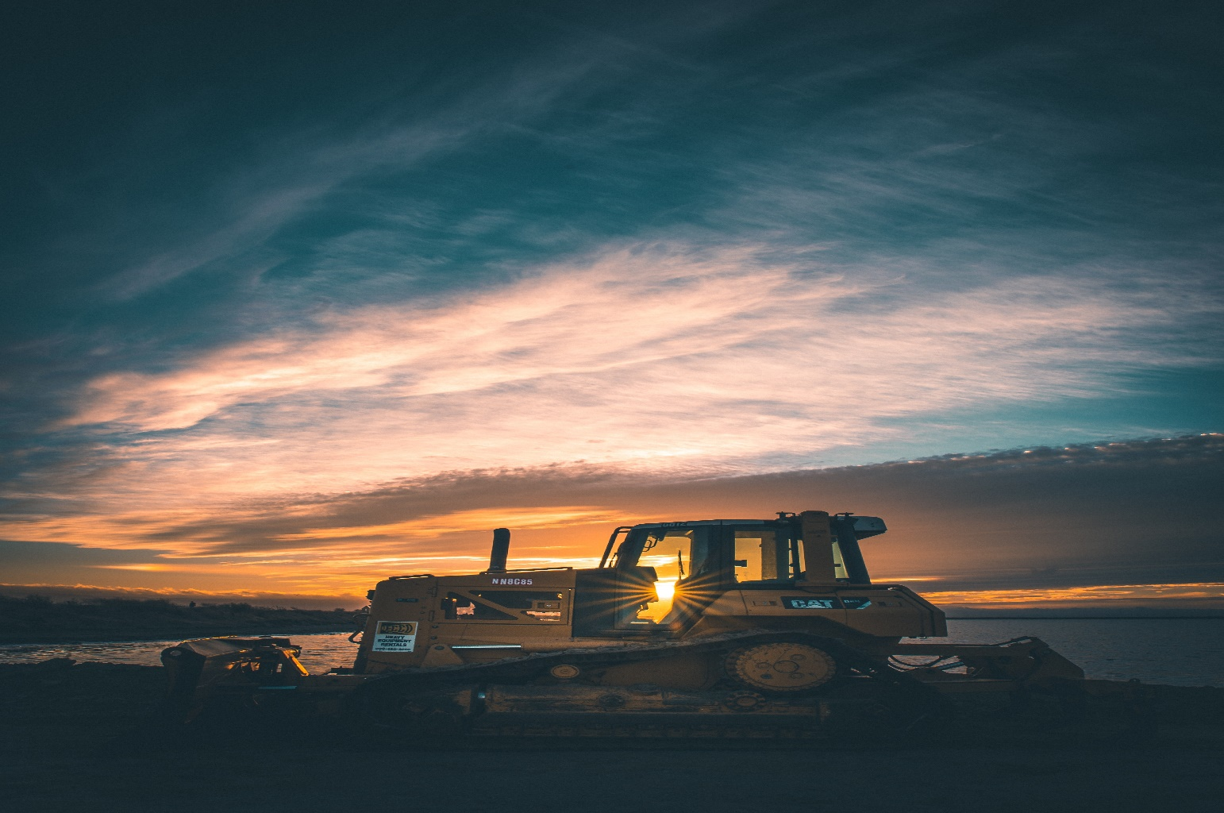
Caterpillar Inc. was founded in 1925 in California, USA, by C.L. Best, when the Holt Manufacturing Company and the C. L. Best Tractor Company merged to create a new entity. It is a heavy equipment and engine company that also offers financial services. CAT has risen to lead the biggest share of the global heavy construction equipment manufacturing industry.
It owns Bucyrus RH400, the front shovel machine that weighs around 980 tons and reigns globally as the world’s largest excavator. This company lovingly stands out as a durable and easy to maintain machinery equipment. Their machines embrace the latest technology geared towards safety and can be used in a wide variety of projects.
Caterpillar Inc. has covered a good number of products and services in the world market. These products in global market include:
- D11 Bulldozer
- 345C L Excavator
- 930G Wheel Loader
- 797f Haul Truck
- C13 Diesel Engine
- C32 Diesel/Gasoline Engine
- C280 Diesel/Gasoline Engine
Key services that are offered by CAT include: Financing, Insurance, Maintenance and Training. The company also licenses and markets a line of clothing and footwear (boots), as well as mobile phones.
Caterpillar products are manufactured in 110 facilities globally, 51 plants of which are located in the United States while 59 are overseas. In Belgium, it produces hydraulic excavators. In France, it produces Track Type Tractors, Track Type Loaders, Wheeled Diggers and Undercarriage components. In Italy it manufactures pavers while in the United Kingdom, it produces Articulated Dump Trucks, Engines and generating sets.
The Caterpillar subsidiaries include: Caterpillar Financial Services, Caterpillar Insurance Holdings, Caterpillar Logistics Services, Caterpillar Marine Power Systems, FG Wilson, Perkins Engines, Progress Rail and Solar Turbines.

2. Komatsu.
Komatsu is a Japanese multinational manufacturer of construction and mining equipment. It is a public company and the second largest company that produce construction equipment in the world after the Caterpillar Inc.

It has its headquarters in Minato, Tokyo, Japan. Komatsu was founded in 1921 by Meitaro Tekeuchi in Komatsu, Ishikawa Prefecture and named after the city of Komatsu.
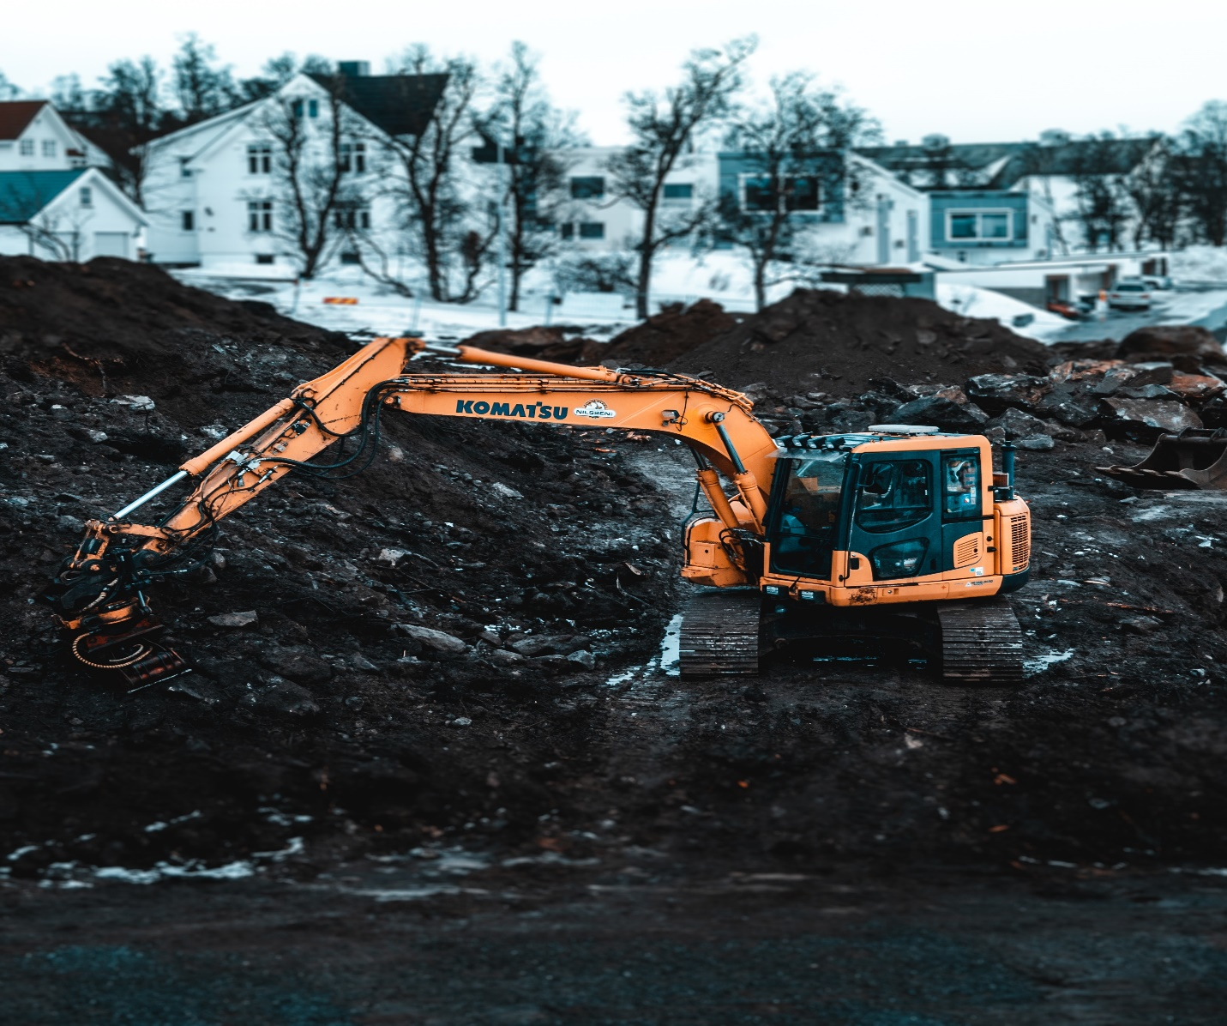
Komatsu produces construction, mining, forestry and military equipment. The company has advanced technologically to produce construction equipment with built-in 3D GPS systems and other technology features.
Komatsu has its manufacturing operations in Japan, Asia, America and Europe, and the company produces key products such as:
- Construction Equipment
- Mining Equipment
- Diesel Engines
- Forestry Equipment
- Industrial Machinery
- Military Vehicles
In the production range, Komatsu makes the largest bulldozer in the world, the D575, it also produces P&H 4800 Electric rope shovel and also 930E Diesel-electric Haulpak truck.
In 2008, Komatsu launched a 360-degree excavator that stores the energy from slew braking to boost power and cut fuel! It is called Komatsu PC200-8 Hybrid. Other brands include Komatsu LAV, Komatsu PC210 LC, Komatsu PC138 US, Bulldozer Komatsu D85 PX and Komatsu HM300 Articulated Dump Truck.
3. Hitachi Construction Machinery Company.
Hitachi is a multinational Japanese company with its headquarters in Chiyoda, Tokyo, Japan. It is a public company that was founded in 1910 by Japanese government as a subsidiary of the Hitachi group. The company engages around the production, sales, and servicing of a diverse range of heavy commercial vehicles.
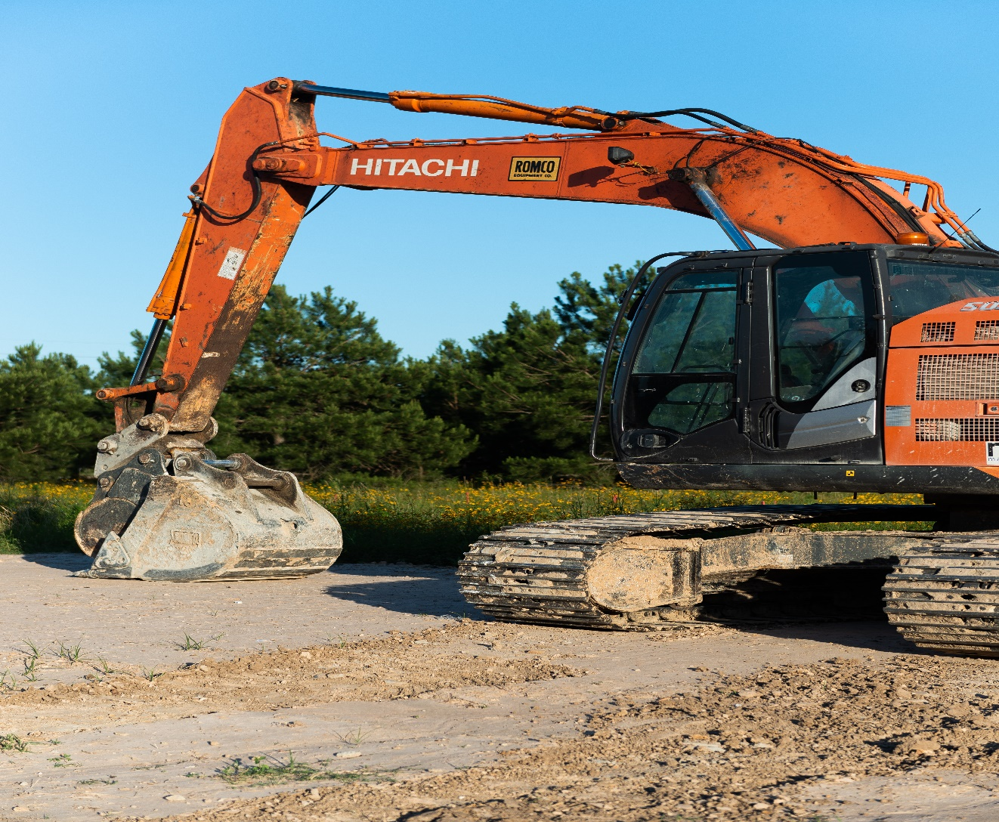
Hitachi has grown populous for its range of machinery such as the mini and large diggers, crawler cranes, light compaction equipment and dump trucks. It designs machines that deliver top performance and highly versatile with good fuel efficiency.
Major products by Hitachi: Industrial Machinery, Heavy Equipment, Power Plants, Elevator and Escalators, Rolling stock, Auto parts, Defense Technology, Artificial Intelligence and Automation, Electronics and Robotics, etc. The company also offers logistics and consultation services.
Hitachi is keen on produces the following heavy equipment:
- Forestry Equipment
- Hydraulic Excavators
- Mechanical And Hydraulic Cranes
- Mining Dump Trucks
- Wheel Loaders
The company also has brands of machines used in the military and defense such as the JGSDF Type 87 Artillery Support Vehicle, JGSDF Type 92 Mine Clearance Vehicle, JGSDF Type 96 120mm self-propelled mortar, and JGSDF Type 99 Artillery Support Vehicle.
Subsidiaries of Hitachi include: Hitachi Vantara, Hitachi Metals, Hitachi Rail, Hitachi Astemo and Hitachi High-Tech.
Hitachi group has of late discontinued its financial services, as well as operations and productions in Hitachi works, Aircraft, Displays such as plasma and LCD Televisions and projectors, Thermal power generation system, Chemical Products and Medical Diagnostic Equipment.

4. Volvo Construction Equipment (Volvo CE).
Volvo Construction Equipment is a company based in Sweden, headquartered in Gothenborg. It was founded in 1832 in Eskilstuna, Sweden by Johan Theofron Munktell, Johan Bolinder and Carl Bolinder. It was formerly and originally known as Bolinder-Munktell, or Volvo BM with respect to its founders.
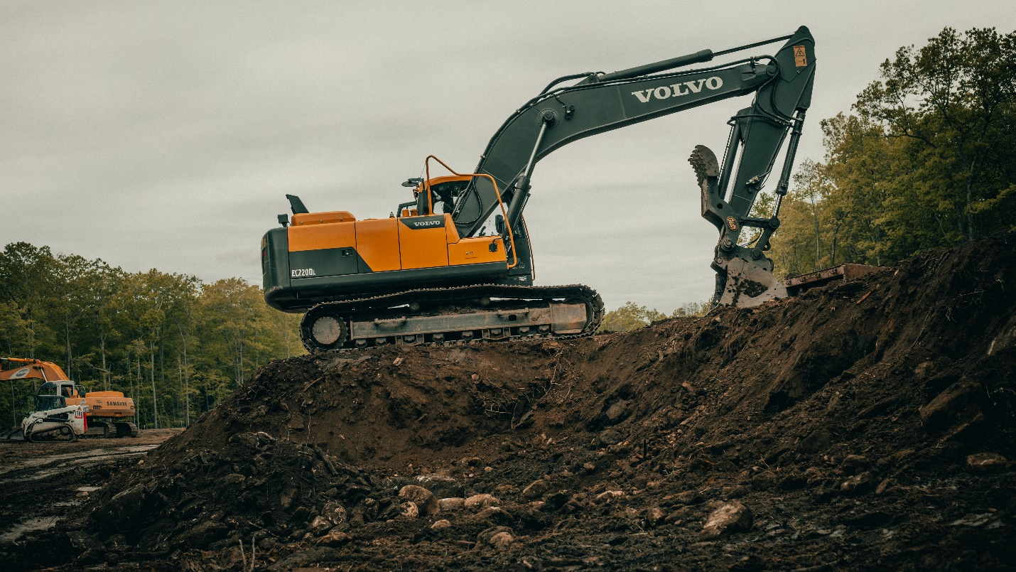
Volvo is a heavy equipment industry that serves the whole world and offers its products to more than 140 countries. It designs, develops, manufactures and sells heavy equipment for companies and industries whose activities and operations revolve around construction, mining or transport of heavy commercial loads.
It offers a wide range of machinery such as compactors, hydraulic excavators, backhoe loaders, skid steers, pavers, loaders and motor graders to the world market. It is also keen on producing demolition equipment, dumpers, articulated haulers, material transfer vehicles, milling equipment, pipe-layers, tack distributers and waste handlers.
Volvo has production facilities in several countries: In the United States of America, Brazil, Scotland, France, Germany, Poland, India, China, Russia and South Korea. And it sells machines under three brands: Volvo, SDLG and Terex trucks.
Lately, in 2020, Volvo CE sold Blow-Knox pavers to Gencor and it has begun to produce and supply the all-electric ECR25 electric machinery for compaction operation to its customers.

5. Terex Corporation.
Terex is a manufacturing company based in American that produces various machinery for lifting and material handling. It was founded in 1933 by George Armington and it has its headquarters in Westport, USA.

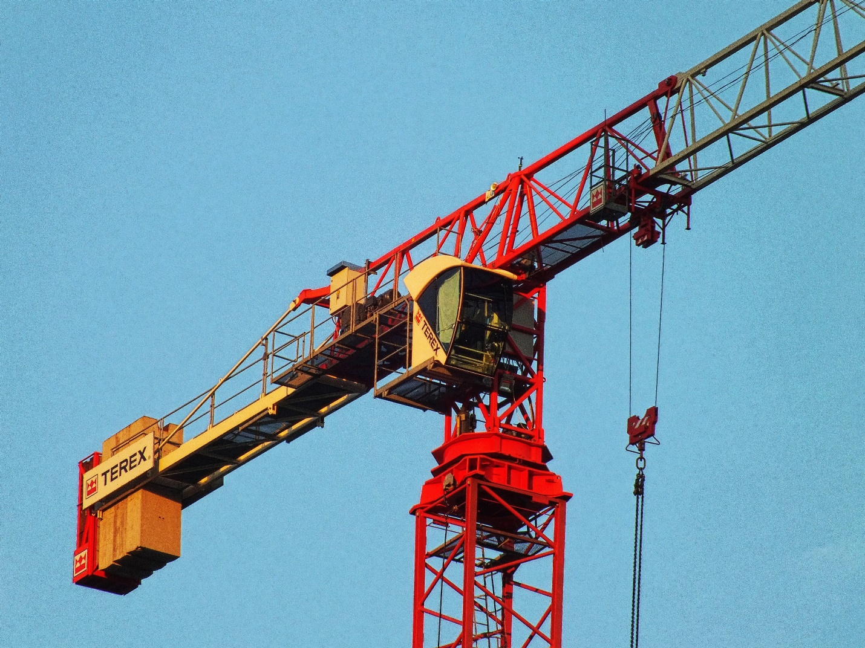
The company manufactures a variety of construction equipment and cranes used for excavation, earth moving, quarrying and mining. Terex also provide financial services.

6. Liebherr.
Liebherr is a German-Swiss multinational company based in Switzerland. Its main production facilities are, however, in Germany. It was founded in 1949 by Hans Liebherr in Kirchdorf, Germany and its main products are construction equipment, agriculture machinery and refrigerators. Liebherr Group is a private company owned by the Liebherr family. It produces a wide range of diggers, making it the top supplier of heavy equipment in Europe.

The company has a typical brand, the Liebherr’s LTM 11200-9.1 which emerges to be the most powerful mobile crane on earth. The company also boasts the longest telescopic boom in the world, which spreads fully to 100 meters. It also produces the BelAZ 75710 and the T 282 B trucks.
Liebherr consists of more than 130 companies that are organized into eleven divisions: Earth moving; mining; mobile, tower and maritime cranes; transportation systems; aerospace; machine tools and automation systems; concrete technology and domestic appliances.

7. Deere & Company.
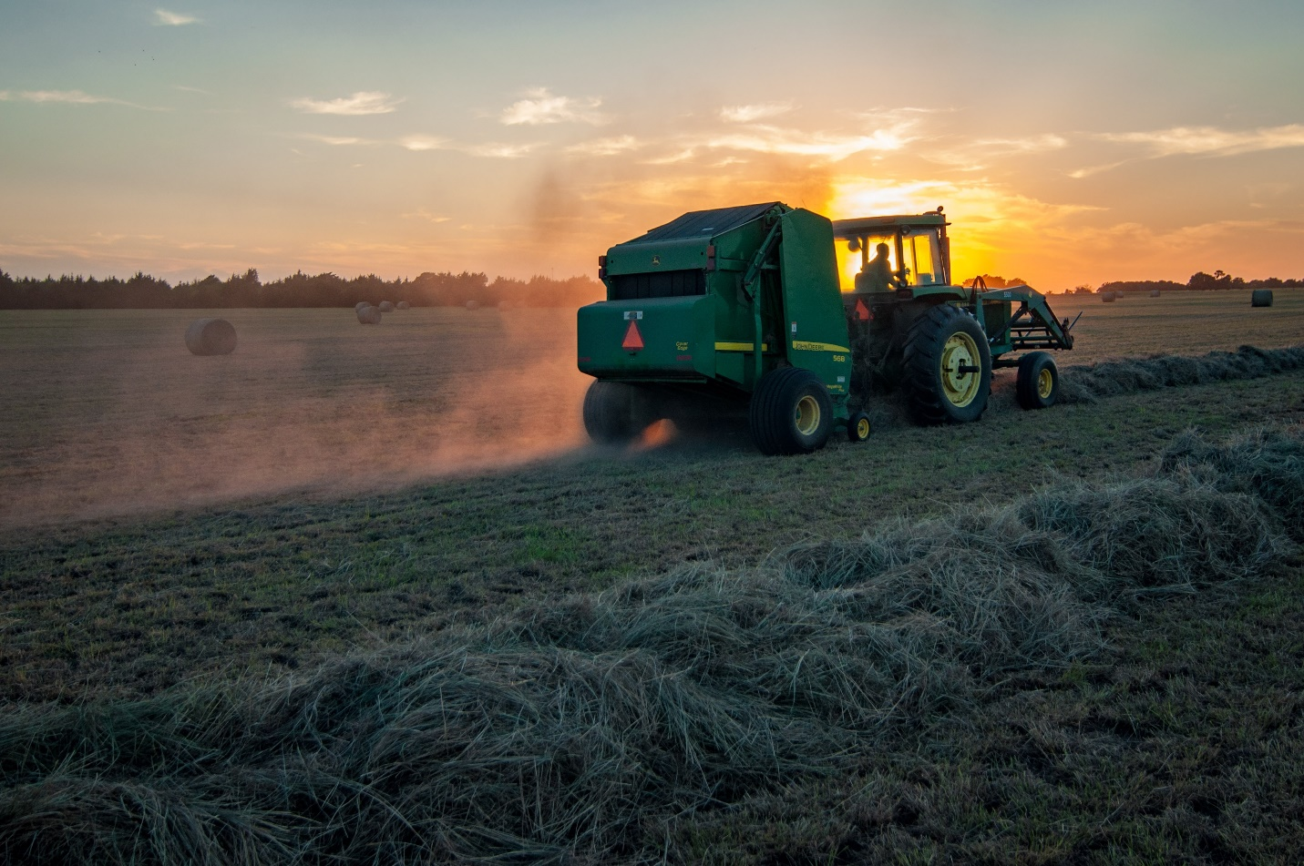
Deere & Company is based in Moline, Illinois, USA. It is an American multinational heavy equipment company that produces a range of construction, agricultural and forestry machinery under the John Deere brand. It was founded in 1837 by John Deere and it has grown to be one of the world’s most popular construction equipment companies.

The company produces machinery that is renowned for ease of service and low cost maintenance. It has one of the renowned brand the 188,716-ib. John Deere 870G LC which has a digging depth of 31ft, 5in. The machine has gained reputation as the largest John Deere Excavator to date.

8. XCMG.
Xuzhou Construction Machinery Group Company Limited is a multinational company based in China. It has headquarters in Xuzhou, Jiangsu. 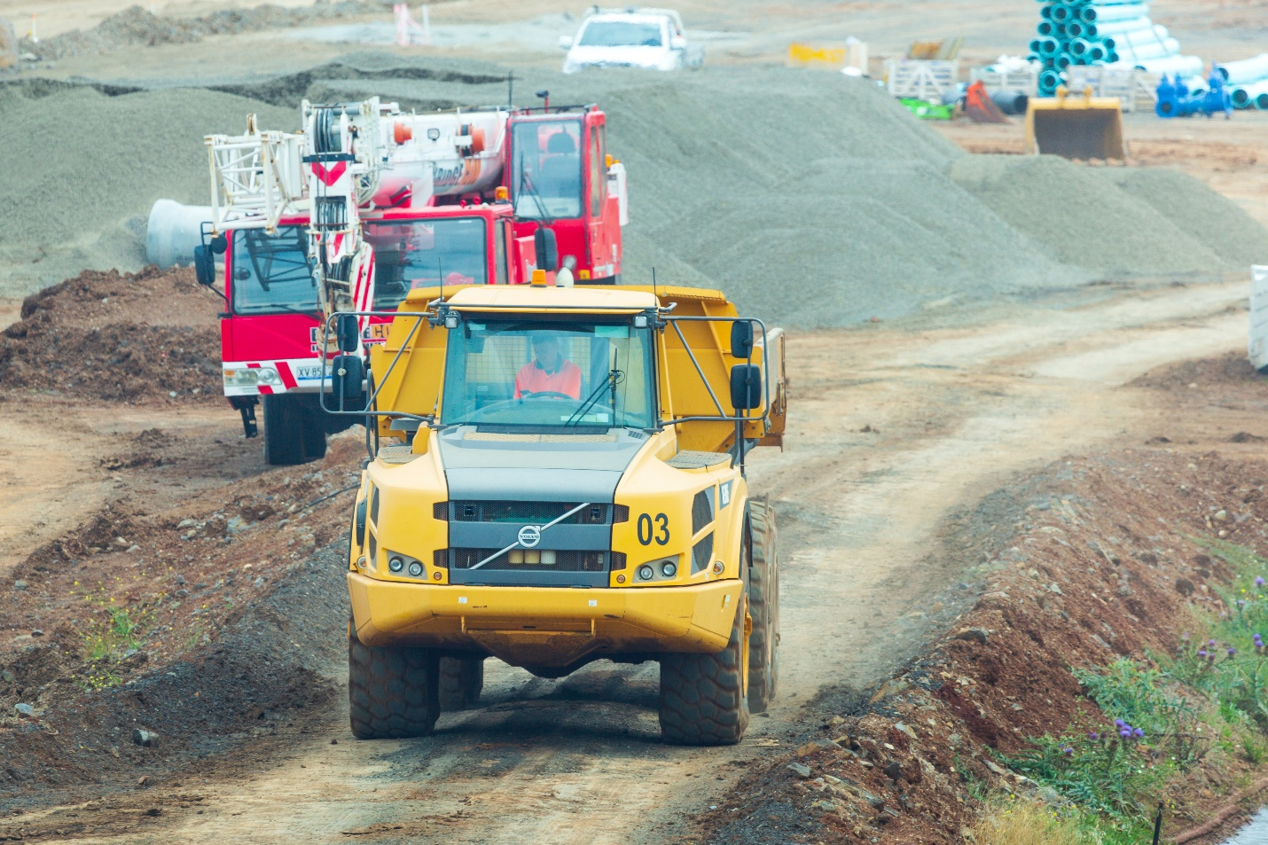

XCMG is the top Chinese company that produce construction equipment and cranes.
Key products of XCMG include hoisting machinery, excavators and compactors.

9. Sany.
Sany Heavy Industry Co. Limited is a multination heavy equipment manufacturing company based in China. It has its headquarters in Changsha, Hunan.
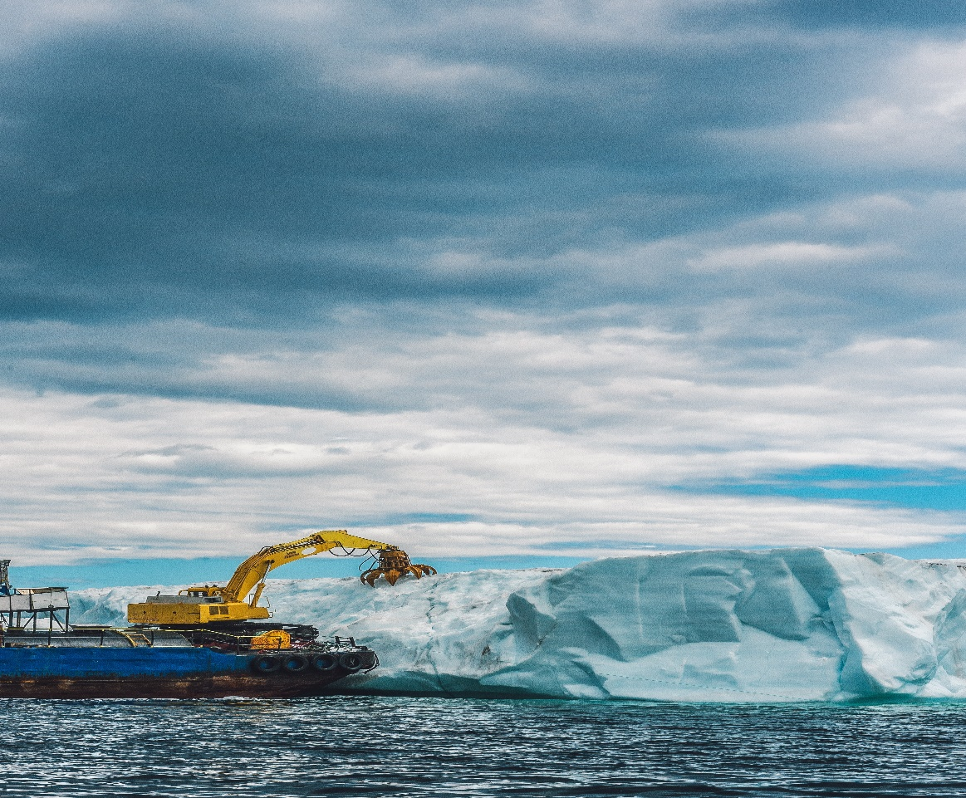
Sany is the third largest heavy equipment producer in the world. It manufactures excavators, cranes, loaders, earthmovers, etc.
The company has a subsidiary; the Putzmeister. It has major parks in China and manufacturing facilities across the world, in Europe, Australia and USA.

10. Doosan Corporation.
Doosan Corporation is based in Seoul, South Korea. It was founded in 1933 in Seoul by Park Seung-jik. It is a multinational company with its main interests geared towards manufacture and supply of heavy construction equipment. 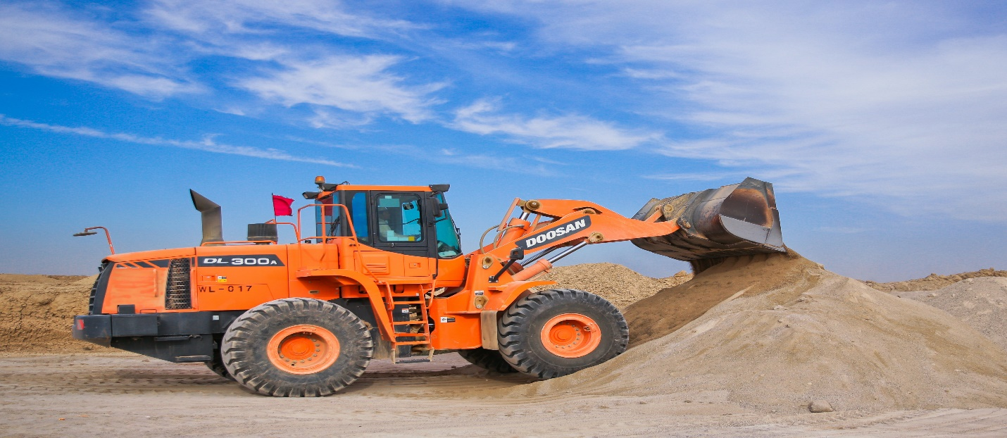

Doosan has subsidiaries that include: Doosan Infracore, Doosan Engineering and Construction, Doosan Heavy Industries and Construction, Doosan Robotics, Doosan Fuel Cell, Doosan Solus, Doosan Mobility Innovation, etc. It has also advanced in electro-materials such as PCB.
Doosan is well renowned globally for its high performance diggers and mini-diggers, wheel loaders, articulated dump trucks, and compact loaders. The company also produces the populous crawler excavators that are mainly built for loading, lifting, digging, scarp handling and mass excavation activities.
The construction equipment and machinery produced by Doosan are popular for their explosive excavating force, great performance, high fuel efficiency and convenient control.

Brands of Construction Equipment Produced by Top Companies in the World.
Every company has brands for its products. Each of the companies already discussed above produce construction equipment that bear their name identities. Better still, companies like the Caterpillar Inc. and Komatsu have special brands that stand out in the global market.
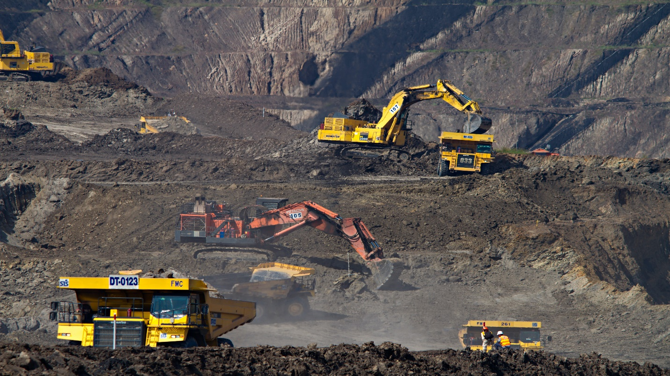
There are also other top flourishing companies that produce heavy construction equipment such as, JCB, Hitachi, Hyundai and Case Construction Equipment also have typical brands that reign the world market.
- Caterpillar: Anchor; AsiaTrack; Cat; Cat Lift Trucks; Cat Reman; FG Wilson; Hindustan; Kemper; M2M; MWM; MaK; Olympian; Perkins; SEM; Progress Rail; etc.
- Komatsu: Komatsu LAV, Komatsu PC210 LC, Komatsu PC138 US, Bulldozer Komatsu D85 PX, Komatsu HM300 Articulated Dump Truck, Komatsu PC200-8 Hybrid etc.
- Liebherr Group: LTM 11200-9.1, BelAZ 75710 and T 282 B trucks.
- JCB: the JCB Fastrac, JCB HMEE.
- Hitachi: JGSDF Type 87 Artillery Support Vehicle, JGSDF Type 92 Mine Clearance Vehicle, JGSDF Type 96 120mm self-propelled mortar, and JGSDF Type 99 Artillery Support Vehicle.
- Case CE: CNH.
- Sany: SY500H.
- XCMG: XCMG LW600K, XCMG RT50.

Why Buy Construction Equipment from Top Companies?
Whether you are leasing or looking into owning a construction equipment for your business project, it is a cool business idea to get it from a reputable source.

5 Reasons to Do Business with Top Companies.
- Companies such as Caterpillar Inc. offer financial services such as insurance.
- Top companies offer regular maintenance services.
- The top companies like caterpillar has its branches all over the world so it is easily accessible.
- Top companies do businesses openly and any hitch is easily noticeable.
- All top companies offer professional training.

